**The Prognostic Maintenance System**

**PROJECT SUMMARY:**

The role and vitality of Energy Security for the prosperity of any nation cannot be overlooked. During the current era of technological advancements, life seems to become stagnant when electricity is unavailable. Availability of electricity for industries, institutions, hospitals, and development of all sectors of life plays a key role. The availability of energy loses its effectiveness, if it is not consistent, cost-effective and socially valuable. Thus achieving such objectives of stable, economical and user-friendly electricity is not possible by merely implementing the power projects without devising an efficient and cost effective operation and maintenance (O&M) scheme. In order to ensure the energy security and generation of economically feasible and sustainable electricity, a robust Prognostics Model for seamless O&M of power projects is required. Therefore, we have developed a robust artificial intelligent prognostic maintenance system that can effectively predict the faults in the bearings

of the hydro power and wind power turbines ahead of time. An efficient model, based on machine learning algorithm has been developed and trained. Real life vibration data generated by the Supervisory Control and Data Acquisition (SCADA) system has been used for the training and testing of the model. The vibration data generated by SCADA is a time series data. Hence, Long Short Term Memory (LSTM) algorithm is used to develop the model, keeping in view its unprecedented performance against such type of data.

**CONTEXT OF THE PROJECT:**

Currently, the hydro power and wind power projects operating in Pakistan have adopted a reactive approach towards fault diagnosis. Maintenance activities are either corrective, that are applied once the fault has already occurred or preventive where scheduled maintenance of the equipment is being carried out at pre-defined time periods. These approaches not only lead to plant downtime but also incur extensive maintenance costs. Also, the plant downtime further adds to the prevailing energy shortfall.

In order to address the aforementioned issues, a proactive approach towards fault diagnosis is required, where the faults are identified ahead of time thereby reducing the plant downtime and the associated maintenance costs. Hence, we have developed a robust and artificial intelligent fault prognostic system using the data generated by the SCADA systems installed at the power projects. This software effectively predicts the faults in the bearings installed at hydropower and wind power projects, ahead of time. The software has been tested both on real data and data generated by a test rig. The performance of the software was evaluated and it was found that the software accurately predicts the bearing faults.

**OBJECTIVE:**

In the current era, where global warming and climate change are considered to be one of the largest threats to mankind, the focus has been shifted towards renewable sources of energy for the generation of electricity rather than the use of fossil fuels. Among these, Hydro power has always been the leading source of energy generation. However, over the past few decades, sources like wind power and solar power have also gained much more importance. The extensive research in the area has led to the development of technological advanced and highly complex power generation machines. On one hand, where this development has increased the efficiency and performance of the equipment, consequently it has also generated the need for developing state of the art operation and maintenance systems. Since, the unaccounted faults and preventive maintenance that lead to equipment and plant downtime are now unaffordable. Hence, the need for a paradigm shift from the conventional reactive approaches of fault rectification towards the proactive approaches of fault identification is being felt. This leads to the need of developing an efficient and robust prognostic maintenance system that can identify the faults ahead of time. Hence, our prognostic maintenance system along with predicting the bearing faults not only aims at reducing the plant downtimes but also decreases the associated maintenance cost.

**INNOVATION:**

The traditional sequential models including the Artificial Neural Networks (ANNs), Hidden Markov Models (HMMs), and Kalman Filters perform remarkably well while dealing with sequential data. However, they fail to address the long term dependencies in the time series data. In sensory data, many noisy or non-discriminative signals can exist between two consecutive informative signals. Consequently, a long delay on a time scale is introduced between important data points. To address the issues of long-term data dependency, the use of Recurrent Neural Networks (RNNs) for handling sequential data has been increased substantially. However, one of the shortcomings associated with RNNs is the problem of gradient exploding and vanishing. Although, RNNs have the ability to store the previous inputs in the network and can be trained using back propagation, their ability to cater long term dependencies in the sequential data is reduced due to the gradient vanishing problem. Consequently, the Long Short Term Memory (LSTM) algorithm was introduced. This algorithm not only prevented the gradient from vanishing or exploding but also addressed the long-term data dependencies by introducing forget gates in the architecture.

LSTMs have the ability to simultaneously carry out representative learning and model training, without having the need for additional domain knowledge. In view of the unprecedented performance against time-series data, our prognostic maintenance system is being developed using LSTM.

σ

σ

σ

tanh

σ

σ

σ

tanh

σ

σ

σ

tanh

**Xt-1**

**Xt**

**Xt+1**

**ht-1**

**ht**

**ht+1**

**Figure:** Structure of the LSTM Model

Table: Characteristics of the LSTM Model

|  |  |
| --- | --- |
| **Type** | Stacked LSTM |
| **No. of Hidden Layers** | Two (02) |
| **No. of Memory Units** | Layer 01: 128  Layer 02: 64 |
| **Optimizer** | Adam |
| **Batch Size** | 50 |
| **No. of Epochs** | 100 |

Furthermore, our software is single handedly capable of predicting the faults both in hydro power and wind power turbines.

**COST EFFECTIVENESS:**

Comparing the implementation costs of the software, the associated costs of unplanned plant downtime and maintenance are very high. The corrective and preventive maintenance costs for

such faults are already very high, let aside the indirect costs associated with the plan shutdown.

Hence, this project shall be highly cost effective and will help substantially in reducing the operation and maintenance costs of the power projects.

**EXPECTED OUTPUT:**

The software effectively predicts the future machine failure states. It efficiently identifies the faults in the bearings of the both hydro and wind power projects, ahead of time. The output include a graphical as well as numerical depiction of future bearing vibration values.

**ABILITY TO SCALE:**

Since, the software has already been trained and tested using real data generated by a SCADA system of the power projects, it is a full-fledged system that can be readily implemented at any hydro and wind power project operating in Pakistan.

**Code Screenshot:**

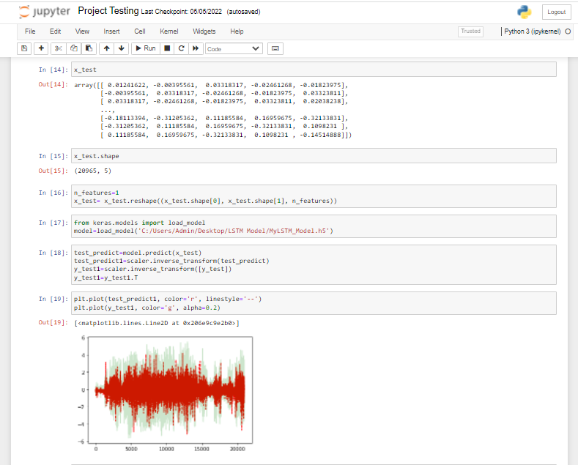

**Data:**

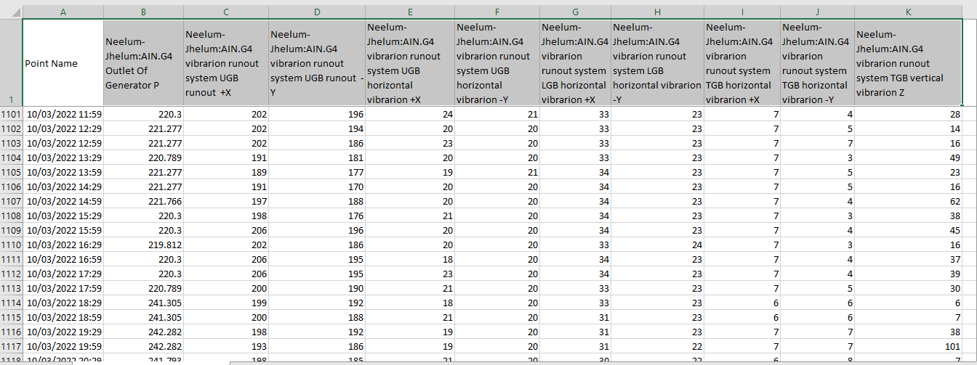

**Software:**

